

**Project Report**

Social Media’s Influence on Students’ Attitudes

**By**

**Group 7**

Janhavi Chitale

Kanishka Ramamoorthy

Karishma Ghiya

**INST 627**

Prof. Jessica Vitak

**TABLE OF CONTENTS**

INTRODUCTION………………………………………………………………… 3

RESEARCH QUESTIONS……………………………………………………….. 4

METHOD………………………………………………………………………….. 5

ANALYSIS…………………………………………………………………………12

DISCUSSION………………………………………………………………………22

REFERENCES……………………………………………………………………..23

1. **INTRODUCTION**

Social networking sites have been gaining tremendous popularity over the past few years and have become a major tool for communication. As of the second quarter of 2015, Facebook had 1.49 billion monthly active users and the number keeps increasing by the minute1. With Facebook playing such a major role in our daily routine, it is important to determine the impact and influence it has on our lives. The usage of Facebook has largely changed over the years. Facebook is no longer just a tool for socializing but is slowly evolving into an information bank aiding people and primarily students to become academically sound. It has the potential to turn into a valuable asset that aids academic prosperity. Facebook offers a number of features to serve this purpose namely, the ability to create study groups, allow instant chat/messaging options between peers/instructors and options to create task lists Student groups largely depend on SNS and primarily Facebook for knowledge sharing and to connect with their faculty and classmates. A 2015 survey conducted by PEW research center revealed that 71% of American adults use Facebook and 74% of these adults are college students2. Another survey of 110 college students showed that 85% of students use Facebook for communicating with other students in their course3. A tremendous amount of knowledge is being transferred through social networking sites. However just like any technology shaped for social interaction and repurposed for learning, a careful and well informed integration process is necessary to provide a foundation for developing new learning activities.

There could be a few limitations to using Facebook for education that could make it a little less effective than classroom learning. Facebook is an interactive learning platform promoting active interactions between peers. Students tend to connect with their peers online for educational purposes while they were a bit more reluctant to connect with their faculty and professors online4. Faculty seem a little less open to the idea of using Facebook for education as compared to students and this might affect the way students use Facebook for learning. However, as the rapid evolution in societal perceptions and uses of the Internet has shown in the last decade, attitudes toward technologies tend to change over time5.

Facebook can heavily aid social interactions and provide a platform for networking. Facebook provides individuals with a way of maintaining and strengthening social ties, which can be highly beneficial in social settings6 Facebook provides rich features for organizing these relationships effectively. The framework of Facebook actually provides free of charge software that were provided by traditional electronic learning. “This is the first time the world has seen this scale and quality of data about human communication”, the team leader of Facebook’s Bell Lab of Data told [MIT Technology Review’s Tom Simonite](http://bit.ly/Nnl1kK) (June 2012). Such a heavy flow of human communication compels the need to verify the impact of these interactions. The interactions can have negative impacts when non group members are denied access to the benefits that members receive7. However most of the interactions are generally perceived to have positive effects8. It is vital to determine the role of social media in a person’s life, the impact of it on relationships and measure what factors in a student’s life govern social media engagement.

1. **RESEARCH QUESTIONS**

**RQ1:**

Are there differences in students’ use of Facebook for school across their year in school?

**MOTIVATION:**

Apart from aiding the socializing process Facebook has provided a platform to serve the academic needs of students. Research indicates that huge populations of undergraduate students in the U.S use social networking sites for academic purposes9i, 9ii. Researches have also found that social networking sites serve as a portal for students to reach out to their classmates and discuss academics formally as well as informally10i, 10ii, 10iii, 10iv. We are interested in analyzing and comparing the studying habits of undergraduate students across their years in school.

**RQ2:**

Is there a correlation between a student’s dependence of FB and his/her social relationship with people on his/her network (family, friends, coworkers, community members and so on)?

**MOTIVATION:**

Facebook is widely being used as a medium to connect with people and as a platform to build mutual bonds. We are interested in analyzing if students who use FB more ardently tend to build better emotional ties with members in their social network than those who don’t.

**RQ3:**

Are students having immediate family members on their FB friend list more likely to change the privacy settings so that only some of their Facebook friends can view specific types of content than students who do not have family members on their friend list?

**MOTIVATION:**

Young adults and teens are sometimes cautious in including their family members in their Facebook friend list or in sharing posts with them. They might want to reveal only a part of their true identity to their family members mainly due to the fear of being judged11. Hence it is only natural for them to wish not to reveal some contents about their social lives to their family, as it could appear inappropriate to them. We are interested in analyzing if this theory holds true on a large scale.

1. **METHOD**

The project is based on the dataset “2010 Facebook Social Capital”, prepared by Jessica Vitak, Nicole B. Ellison and Charles Steinfield from Michigan State University12. The survey, conducted in April 2010, was hosted online on SurveyGizmo with a random sample of 2,000 undergraduate students from Michigan State, out of which 325 students completed the survey at 16.3% completion rate. The participants were offered either iTunes or one of twenty $15 gift certificates to Amazon.com.

The demographics of our dataset is displayed in the Table 1 below:

|  |  |  |
| --- | --- | --- |
| **Demographics** | **Mean or % (N)** | **S.D.** |
| Gender |  | 0.482 |
| Male | 36.2% (158) |  |
| Female | 63.2% (276) |  |
| Age | 22.68 | 5.425 |
| Ethnicity |  | 1.66 |
| White | 78.0% (341) |  |
| Non-White | 20.4% (89) |  |
| Not Disclosed | 1.1% (5) |  |
| Member of fraternity or sorority | 5.7% (25) |  |
| International Student | 8.5% (37) |  |
| Out-of-State Student | 18.1% (79) |  |
| Residence |  |  |
| On Campus | 41.6% (182) |  |
| Off Campus | 57.9% (253) |  |
| Members of Facebook | 392 |  |
| Hours spent on the Internet Each Day (Weekday) | 4.05 hrs | 2.6 hrs |
| Hours spent on the Internet Each Day (Weekend) | 3.52 hrs | 2.45 hrs |

Table 1: Demographics of Dataset

This dataset was of particular interest to us as it revolved around the issue of social media’s influence on the social attitudes of college students. The dataset spans a range of questions that capture the difference in opinions of students on the relationship between Facebook usage and social behavior of students.

The dataset had quite a lot of missing values and thus required cleaning. There were a total of 437 responses that we had. Out of these 380 people were members of Facebook. There were a couple of missing values for the group of items that we used to form the scales (Facebook in Education, Facebook Intensity, Social Provision). For those scales, when there were many items with missing data, we unselected those cases and for only 1 or 2 items with missing data, we replaced the values by the mean. For other variables with missing data, we simply unselected those cases, as the number of such cases was not too high (about 10 to 12 out of 437 responses). 392 students are members on Facebook, 10 students are not members and 35 entries have missing values for that variable.

|  |  |
| --- | --- |
| **Research Question:** | **No of cases after data cleaning:** |
| RQ1 | 370 |
| RQ2 | 389 |
| RQ3 | 380 |

Table 2: Number of cases for each research question after data cleaning

**Measures**

**RQ1**

**Students Year in School**

A nominal variable with categories assigned for the different years in school is used to determine the year of school the respondent is currently studying in. There are 6 defined categories while include freshmen, sophomores, juniors, seniors, panel only, masters and doctorate students. In this particular study, we have only considered the respondents in the undergraduate school and hence concentrated on the categories: freshmen, sophomores, juniors and seniors .

**Students’ use of Facebook for School**

The students’ use of Facebook for school was captured through 9 questions asked to respondents in the dataset. These questions covered various topics like using Facebook to arrange meetings, sharing information etc. The Facebook_In_School scale was computed by using the mean of all the 9 variables. The Cronbach’s Alpha value was found out to be 0.894 and hence the scale is reliable.

|  |  |
| --- | --- |
| **Reliability Statistics** | |
| Cronbach's Alpha | N of Items |
| .894 | 9 |

|  |  |  |  |
| --- | --- | --- | --- |
| **Scale Statistics** | | | |
| Mean | Variance | Std. Deviation | N of Items |
| 27.06 | 55.918 | 7.478 | 9 |

|  |  |  |  |
| --- | --- | --- | --- |
| **Item Statistics** | | | |
|  | Mean | Std. Deviation | N |
| Arrange a study group or meeting. | 3.58 | 1.189 | 370 |
| Collaborate on an assignment in a way that your instructor would like.  Collaborate on an assignment in a way that your instructor might not like. | 3.32  2.27 | 1.239  1.017 | 370 |
| 370 |
|  |  |  |  |
| Share homework answers in a way the instructor would not approve. | 2.04 | 1.007 | 370 |
| Share answers from a test with someone who has yet to take it. | 1.71 | .832 | 370 |
| Contact another student with a question related to a class or schoolwork. | 3.74 | 1.202 | 370 |
| Discuss classes or schoolwork. | 3.70 | 1.186 | 370 |
| Do something on Facebook as part of an assigned class exercise. | 3.04 | 1.257 | 370 |
| Ask a classmate for help in a class. | 3.66 | 1.175 | 370 |

|  |  |  |  |  |
| --- | --- | --- | --- | --- |
| **Item-Total Statistics** | | | | |
|  | Scale Mean if Item Deleted | Scale Variance if Item Deleted | Corrected Item-Total Correlation | Cronbach's Alpha if Item Deleted | |
| Arrange a study group or meeting. | 23.48 | 43.399 | .709 | .877 | |
| Collaborate on an assignment in a way that your instructor would like. | 23.74 | 41.992 | .772 | .872 | |
| Collaborate on an assignment in a way that your instructor might not like. | 24.78 | 47.113 | .557 | .889 | |
| Share homework answers in a way the instructor would not approve. | 25.02 | 47.566 | .528 | .891 | |
| Share answers from a test with someone who has yet to take it. | 25.34 | 50.502 | .399 | .898 | |
| Contact another student with a question related to a class or schoolwork. | 23.32 | 42.705 | .749 | .874 | |
| Discuss classes or schoolwork. | 23.35 | 42.766 | .757 | .873 | |
| Do something on Facebook as part of an assigned class exercise. | 24.02 | 44.062 | .615 | .885 | |
| Ask a classmate for help in a class. | 23.40 | 42.826 | .762 | .873 | |

**RQ2**

**Dependence on Facebook**

The dependence of the students on Facebook was determined by using the Facebook Intensity Scale13. This scale includes variables like number of friends on the site; time spent on the site, as well as six Likert type questions about the students’ emotional engagement with Facebook and integration of the site into their daily lives. To compute the scale, the variable “Approximately how many number of friends do you have?” was transformed into a 10-point ordinal scale. The scale was computed by taking the mean of all the 7 variables. The scale was found out to be reliable as the Cronbach’s Alpha was 0.7

|  |  |  |  |
| --- | --- | --- | --- |
| **Reliability Statistics** | | | |
| Cronbach's Alpha | | N of Items | |
| .735 | | 8 | |
| **Scale Statistics** | | | | | |
| Mean | Variance | | Std. Deviation | | N of Items |
| 32.5006 | 60.394 | | 7.77137 | | 8 |

|  |  |  |  |
| --- | --- | --- | --- |
| **Item Statistics** | | | |
|  | Mean | Std. Deviation | N | |
| SMEAN (In the past week on average approximately how much time PER DAY) | 4.8568 | 3.27169 | 389 | |
| SMEAN (Facebook is part of my everyday activity) | 3.9203 | 1.03362 | 389 | |
| SMEAN (I am proud to tell people I am on Facebook) | 3.3907 | .92587 | 389 | |
| SMEAN (Facebook has become part of my daily routine) | 3.9093 | 1.02523 | 389 | |
| SMEAN (I feel out of touch when I haven’t logged onto Facebook for a while) | 3.1517 | 1.22058 | 389 | |
| SMEAN (I feel I am part of the Facebook community) | 3.4260 | 1.01806 | 389 | |
| SMEAN (I would be sorry if Facebook shut down) | 3.5168 | 1.15393 | 389 | |
| SMEAN (Facebook_Friends_Categorical) | 6.3290 | 1.99734 | 389 | |

|  |  |  |  |  |
| --- | --- | --- | --- | --- |
| **Item-Total Statistics** | | | | |
|  | Scale Mean if Item Deleted | Scale Variance if Item Deleted | Corrected Item-Total Correlation | Cronbach's Alpha if Item Deleted |
| SMEAN (In the past week on average approximately how much time PER DAY) | 27.6439 | 32.448 | .454 | .780 |
| SMEAN (Facebook is part of my everyday activity) | 28.5803 | 49.052 | .681 | .684 |
| SMEAN (I am proud to tell people I am on Facebook) | 29.1099 | 52.530 | .490 | .711 |
| SMEAN (Facebook has become part of my daily  Routine) | 28.5913 | 49.459 | .656 | .687 |
| SMEAN (I feel out of touch when I haven’t logged onto Facebook for a while) | 29.3490 | 48.505 | .587 | .688 |
| SMEAN (I feel I am part of the Facebook community) | 29.0747 | 50.856 | .556 | .700 |
| SMEAN (I would be sorry if Facebook shut down) | 28.9838 | 51.286 | .445 | .711 |
| SMEAN (Facebook_Friends_Categorical) | 26.1716 | 46.812 | .336 | .733 |

**Social Relationships**:

The Social Provision Scale14,15 was used to determine the nature of the social relationships of the students in their network. Weiss originally devised the Social Provision Scale in 1973 with 24 variables. These variables were subdivided into 6 subscales: guidance (advice or information), reliable alliance (assurance that others can be counted on in times of stress), reassurance of worth (recognition of one’s competence), attachment (emotional closeness), social integration (a sense of belonging to a group of friends), and opportunity for nurturance (providing assistance to others). According to the data available, we have only 12 out of the 24 variables, which include the Guidance and the reliability scale, and a few other variables. Hence, for this study, we are going to consider only the 12 available variables to form the scale. Out of the 12 variables, 6 variables are variables with negative Likert Scales and hence they were reversed. The scale was then computed by taking the mean of all the 12 variables.

|  |  |  |
| --- | --- | --- |
| **Reliability Statistics** | | |
| Cronbach's Alpha | Cronbach's Alpha Based on Standardized Items | N of Items |
| .908 | .914 | 12 |

|  |  |  |  |
| --- | --- | --- | --- |
| **Scale Statistics** | | | |
| Mean | Variance | Std. Deviation | N of Items |
| 43.38 | 29.571 | 5.438 | 12 |

|  |  |  |  |
| --- | --- | --- | --- |
| **Item Statistics** | | | |
|  | Mean | Std. Deviation | N |
| SMEAN (There are people I can depend on to help me if I really need it) | 3.72 | .541 | 389 |
| SMEAN (I have close relationships that provide me with as sense of emotional well being) | 3.56 | .629 | 389 |
| SMEAN (There is someone I could talk to about important decisions in my life) | 3.66 | .552 | 389 |
| SMEAN (There is a trustworthy person I could turn to for advice if I we) | 3.67 | .570 | 389 |
| SMEAN (I feel a strong emotional bond with at least one other person) | 3.70 | .560 | 389 |
| SMEAN (There are people I can count on in an emergency) | 3.73 | .508 | 389 |
| SMEAN (There is no one I can turn to for guidance in times of stress reversed) | 3.57 | .683 | 389 |
| SMEAN (If something went wrong no one would come to my assistance reversed) | 3.66 | .613 | 389 |
| SMEAN (There is no one who shares my interests and concerns reversed) | 3.54 | .740 | 389 |
| SMEAN (There is no one I can depend on for aid if I really need it reversed) | 3.65 | .693 | 389 |

|  |  |  |  |  |  |
| --- | --- | --- | --- | --- | --- |
| **Item-Total Statistics** | | | | | |
|  | Scale Mean if Item Deleted | Scale Variance if Item Deleted | Corrected Item-Total Correlation | Squared Multiple Correlation | Cronbach's Alpha if Item Deleted |
| SMEAN (There are people I can depend on to help me if I really need it) | 39.65 | 25.574 | .678 | .573 | .899 |
| SMEAN (I have close relationships that provide me with a sense of emotional well being) | 39.81 | 25.128 | .642 | .522 | .900 |
| SMEAN (There is someone I could talk to about important decisions in my life) | 39.72 | 25.385 | .697 | .606 | .898 |
| SMEAN (There is a trustworthy person I could turn to for advice if I we) | 39.71 | 25.136 | .719 | .604 | .897 |
| SMEAN( I feel a strong emotional bond with at least one other person) | 39.68 | 25.288 | .705 | .576 | .898 |
| SMEAN (There are people I can count on in an emergency) | 39.64 | 25.848 | .671 | .532 | .900 |
| SMEAN (There is no one I can turn to for guidance in times of stress reversed) | 39.80 | 24.988 | .603 | .494 | .902 |
| SMEAN (If something went wrong no one would come to my assistance reversed) | 39.71 | 25.299 | .632 | .531 | .900 |
| SMEAN (There is no one who shares my interests and concerns reversed) | 39.84 | 24.735 | .583 | .358 | .903 |
| SMEAN (There is no one I can depend on for aid if I really need it reversed) | 39.73 | 24.866 | .611 | .454 | .902 |
| SMEAN (There is no one I feel comfortable talking about problems with reversed) | 39.81 | 24.183 | .713 | .567 | .896 |
| SMEAN (I lack a feeling of intimacy with another person reversed) | 40.03 | 24.246 | .551 | .372 | .907 |

**RQ3**

**Selective Privacy Settings**

This measure is obtained by using a variable in the dataset where the respondent is asked if they have ever changed their privacy settings on Facebook such that only some of their friends can view their posts on Facebook.

**Presence of Family Members on Facebook**

A question in the dataset enquires about the nature of the friends present in any respondent’s friend list. Having immediate family members as friends is a category in the answers of the above question. This measure is used along with the selective privacy settings to find any relation between them.

1. **Analysis**

**Research Question 1:**

**HYPOTHESIS:**

Null Hypothesis (H0):

Student’s use of FB for school is same across all years in school

μfreshmen = μsophomore = μjunior = μsenior

Alternate Hypothesis (Ha):

At least one population mean is not equal

μfreshmen ≠ μsophomore

μfreshmen ≠ μjunior

μfreshmen ≠ μsenior

μsophomore ≠ μjunior

μsophomore ≠ μsenior

μjunior ≠ μsenior

For the above analysis, the **independent variable (IV)** is ‘**What year in school are you?’**  and **dependent variable** **(DV)** is ‘**Facebook in School scale’**. The independent variable is categorical (or nominal, to be specific) with more than two levels and dependent variable being a scale, is continuous. Thus a One-way Anova is conducted to analyze the relationship between the variables.

**ANOVA’ S ASSUMPTIONS:**

1. **Normality:**

Looking at descriptive statistics of each of the above variables, we see that this assumption is not violated. For Facebook_in_education_scale, the values of mean and median are comparable and the skewness is -0.947, which can be considered to be normal. Acceptable range for skewness can be considered as -1 to 1.

|  |  |  |
| --- | --- | --- |
| **Statistics** | | |
| Facebook_in_education_scale | | |
| N | Valid | 285 |
| Missing | 0 |
| Mean | | 3.2412 |
| Median | | 3.3333 |
| Mode | | 3.33 |
| Std. Deviation | | .65722 |
| Variance | | .432 |
| Skewness | | -.947 |
| Std. Error of Skewness | | .144 |
| Kurtosis | | 1.768 |
| Std. Error of Kurtosis | | .288 |

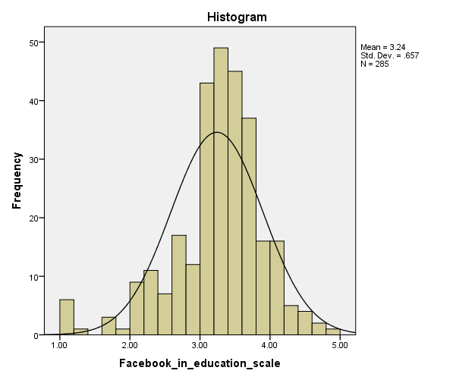

And for the categorical variable also, the distribution is normal, skewness being only -0.031.

|  |  |  |
| --- | --- | --- |
| **Statistics** | | |
| What year in school are you? | | |
| N | Valid | 285 |
| Missing | 0 |
| Mean | | 2.55 |
| Median | | 3.00 |
| Mode | | 4 |
| Std. Deviation | | 1.117 |
| Variance | | 1.248 |
| Skewness | | -.031 |
| Std. Error of Skewness | | .144 |
| Kurtosis | | -1.360 |
| Std. Error of Kurtosis | | .288 |

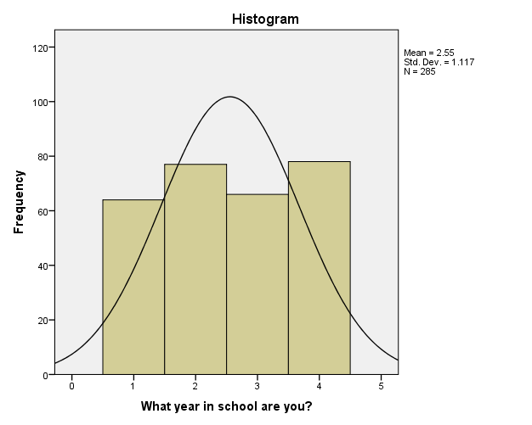

Thus each variable is normally distributed and this assumption is not violated.

1. **Homogeneity of variance:**

|  |  |  |  |
| --- | --- | --- | --- |
| **Test of Homogeneity of Variances** | | | |
| FACEBOOK_IN_EDUCATION_SCALE_1 | | | |
| Levene Statistic | df1 | df2 | Sig. |
| 2.955 | 3 | 281 | .033 |

Levene’s test is significant (< 0.05) and thus test of Homogeneity of variance is violated. This is not a strictly enforced test, since ANOVA tests are usually robust against violations of homogeneity.

1. **Independence of Observations:**

All samples are drawn independently of each other, since no person belonging to one year in school can be represented in a different year. Hence this assumption is not violated.

After running the One-way Anova test, we get the following output.

|  |  |  |  |  |  |  |  |  |
| --- | --- | --- | --- | --- | --- | --- | --- | --- |
| **Descriptives** | | | | | | | | |
| FACEBOOK_IN_EDUCATION_SCALE_1 | | | | | | | | |
|  |  |  |  |  |  | |  |  |
|  | N | Mean | Std. Deviation | Std. Error | 95% Confidence Interval for Mean | | Minimum | Maximum |
| Lower Bound | Upper Bound |
| 1 | 64 | 3.3320 | .58770 | .07346 | 3.1852 | 3.4788 | 1.78 | 4.67 |
| 2 | 77 | 3.3725 | .59409 | .06770 | 3.2376 | 3.5073 | 1.11 | 4.89 |
| 3 | 66 | 3.1669 | .58607 | .07214 | 3.0228 | 3.3110 | 1.33 | 4.44 |
| 4 | 78 | 3.0972 | .79837 | .09040 | 2.9172 | 3.2772 | 1.00 | 4.33 |
| Total | 285 | 3.2404 | .66031 | .03911 | 3.1635 | 3.3174 | 1.00 | 4.89 |

|  |  |  |  |  |  |
| --- | --- | --- | --- | --- | --- |
| **ANOVA** | | | | | |
| FACEBOOK_IN_EDUCATION_SCALE_1 | | | | | |
|  | Sum of Squares | df | Mean Square | F | Sig. |
| Between Groups | 3.836 | 3 | 1.279 | 2.995 | .031 |
| Within Groups | 119.989 | 281 | .427 |  |  |
| Total | 123.825 | 284 |  |  |  |

The significance level of 0.031 (< 0.05 α-level) between groups means that there is a statistically significant difference or variance in students’ use of Facebook for education across their years in school. We reject the null hypothesis of equal means across groups. Post hoc tests will help identify where these differences exists between the groups.

|  |  |  |  |  |
| --- | --- | --- | --- | --- |
| **Robust Tests of Equality of Means** | | | | |
| FACEBOOK_IN_EDUCATION_SCALE_1 | | | | |
|  | Statistica | df1 | df2 | Sig. |
| Welch | 2.852 | 3 | 154.785 | .039 |
| Brown-Forsythe | 3.063 | 3 | 267.311 | .029 |
| a. Asymptotically F distributed. | | | | |

These tests are useful if homogeneity of variance is violated. Brown (significance level = .029) and Welch (significance level = .039) test show that there are statistically significant differences in student’s use of FB for education across their years in school.

**Post Hoc Tests**

|  |  |  |  |  |  |  |  |
| --- | --- | --- | --- | --- | --- | --- | --- |
| **Multiple Comparisons** | | | | | | | |
| Dependent Variable: FACEBOOK_IN_EDUCATION_SCALE_1 | | | | | | | |
|  | (I) What year in school are you? | (J) What year in school are you? | Mean Difference (I-J) | Std. Error | Sig. | 95% Confidence Interval | |
|  | Lower Bound | Upper Bound |
| Scheffe | 1 | 2 | -.04044 | .11053 | .987 | -.3513 | .2704 |
| 3 | .16515 | .11464 | .558 | -.1573 | .4876 |
| 4 | .23481 | .11021 | .211 | -.0752 | .5448 |
| 2 | 1 | .04044 | .11053 | .987 | -.2704 | .3513 |
| 3 | .20560 | .10961 | .320 | -.1027 | .5139 |
| 4 | .27525 | .10498 | .078 | -.0200 | .5705 |
| 3 | 1 | -.16515 | .11464 | .558 | -.4876 | .1573 |
| 2 | -.20560 | .10961 | .320 | -.5139 | .1027 |
| 4 | .06965 | .10929 | .939 | -.2377 | .3770 |
| 4 | 1 | -.23481 | .11021 | .211 | -.5448 | .0752 |
| 2 | -.27525 | .10498 | .078 | -.5705 | .0200 |
| 3 | -.06965 | .10929 | .939 | -.3770 | .2377 |

**Homogeneous Subsets**

|  |  |  |  |
| --- | --- | --- | --- |
| **FACEBOOK_IN_EDUCATION_SCALE_1** | | | |
|  | What year in school are you? | N | Subset for alpha = 0.05 |
|  | 1 |
| Tukey Ba,b | 4 | 78 | 3.0972 |
| 3 | 66 | 3.1669 |
| 1 | 64 | 3.3320 |
| 2 | 77 | 3.3725 |
| Scheffea,b | 4 | 78 | 3.0972 |
| 3 | 66 | 3.1669 |
| 1 | 64 | 3.3320 |
| 2 | 77 | 3.3725 |
| Sig. |  | .102 |
| Means for groups in homogeneous subsets are displayed. | | | |
| a. Uses Harmonic Mean Sample Size = 70.691. | | | |
| b. The group sizes are unequal. The harmonic mean of the group sizes is used. Type I error levels are not guaranteed. | | | |

The table above of the Post-Hoc tests shows that there is no statistically significant difference in student’s use of Facebook for education between any two pairs of groups.

**Research Question 2:**

**HYPOTHESIS:**

Null Hypothesis (H0):

There is no relationship between a student’s dependence on FB and his/her social relationship with people on his/her network.

Alternate Hypothesis (Ha):

There is a relationship between a student’s dependence on FB and his/her social relationships with people on his/her network.

Facebook_Intensity_Scale and Social_Provisions_Scale were calculated as mentioned in the measures section of the methods. As seen from the descriptive statistics, the Facebook Intensity Scale can be considered to be normal. For the Social Provisions Scale, to make the data normalized, we tried to transform the variable by taking the log or square root but in these cases the skewness increased considerably. Hence, since the original data has a skewness value between the standard -1.5 to 1.5, we decided to use the same16.

|  |  |  |  |
| --- | --- | --- | --- |
| **Statistics** | | | |
|  | | Facebook_Intensity_Scale_Computed | Social_Provisions_Scale |
| N | Valid | 389 | 389 |
| Missing | 0 | 0 |
| Mean | | 4.6429 | 3.6146 |
| Median | | 4.7143 | 3.7500 |
| Mode | | 5.14 | 4.00 |
| Std. Deviation | | 1.11020 | .45316 |
| Variance | | 1.233 | .205 |
| Skewness | | -.244 | -1.525 |
| Std. Error of Skewness | | .124 | .124 |
| Kurtosis | | .225 | 3.038 |
| Std. Error of Kurtosis | | .247 | .247 |

|  |  |  |  |  |
| --- | --- | --- | --- | --- |
| **Statistics** | | | | |
|  | | Social_Provisions_Scale | Social_Provisions_Scale_Log | Social_Provisions_Scale_SquareRoot |
| N | Valid | 389 | 389 | 389 |
| Missing | 0 | 0 | 0 |
| Mean | | 3.6146 | .5539 | 1.8969 |
| Median | | 3.7500 | .5740 | 1.9365 |
| Mode | | 4.00 | .60 | 2.00 |
| Std. Deviation | | .45316 | .06373 | .12747 |
| Variance | | .205 | .004 | .016 |
| Skewness | | -1.525 | -2.756 | -1.969 |
| Std. Error of Skewness | | .124 | .124 | .124 |
| Kurtosis | | 3.038 | 15.209 | 6.705 |
| Std. Error of Kurtosis | | .247 | .247 | .247 |

|  |  |  |  |
| --- | --- | --- | --- |
| **Variables Entered/Removeda** | | | |
| Model | Variables Entered | Variables Removed | Method |
| 1 | Social_Provisions_Scaleb | . | Enter |
| a. Dependent Variable: Facebook_Intensity_Scale_Computed | | | |
| b. All requested variables entered. | | | |

|  |  |  |  |  |
| --- | --- | --- | --- | --- |
| **Model Summaryb** | | | | |
| Model | R | R Square | Adjusted R Square | Std. Error of the Estimate |
| 1 | .125a | .016 | .013 | 1.10286 |
| a. Predictors: (Constant), Social_Provisions_Scale | | | | |
| b. Dependent Variable: Facebook_Intensity_Scale_Computed | | | | |

|  |  |  |  |  |  |  |
| --- | --- | --- | --- | --- | --- | --- |
| **ANOVAa** | | | | | | |
| Model | | Sum of Squares | df | Mean Square | F | Sig. |
| 1 | Regression | 7.541 | 1 | 7.514 | 6.178 | .013b |
| Residual | 470.709 | 387 | 1.216 |  |  |
| Total | 478.224 | 388 |  |  |  |
| a. Dependent Variable: Facebook_Intensity_Scale_Computed | | | | | | |
| b. Predictors: (Constant), Social_Provisions_Scale | | | | | | |

**Coefficientsa**

|  |  |  |  |  |  |  |
| --- | --- | --- | --- | --- | --- | --- |
| Model | | Unstandardized Coefficients | | Standardized Coefficients | t | Sig. |
| B | Std. Error | Beta |
| 1 | (Constant) | 3.5333 | .450 |  | 7.849 | .000 |
| Social_Provisions_Scale | .307 | .124 | .125 | 2.486 | .011 |

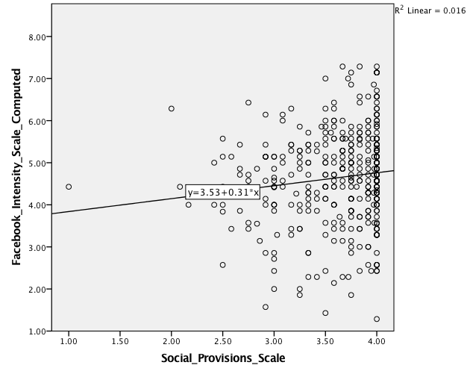

From the model summary we can see that the correlation coefficient has a value of 0.121 and R2 has a value of 0.015.

Also, from the ANOVA,

F(1,435) = 6.459, p = 0.011.

As p <0.05, the test is significant and hence we can reject the null hypothesis.

Thus we can conclude that the dependence on facebook and social relationships are mildly positively correlated with each other with a very small correlation factor of 0.12. Also, only 1.5 percent of the variance in the dependence of facebook can be explained by the variance of the nature of social relationships.

From the coefficients table or from the scatter plot, we can get the equation of the regression line as

Facebook Dependency = 0.3 (Nature of Social relationships) + 3.53

So, we can infer that for every one-unit increase in the positive nature of social relationships,we expect a 0.3 increase in the dependence on facebook.

**Research Question 3:**

**HYPOTHESIS:**

Null Hypothesis (H0):

Students having immediate family members on their friend list are not likely to change their privacy settings so that only some of their Facebook friends can see the content they share.

Alternate Hypothesis (Ha):

Students having immediate family members on their friend list are likely to change their privacy settings so that only some of their Facebook friends can see the content they share.

For the above analysis, the **independent variable (IV)** is : **Having Immediate family member in friend list** and **dependent variable** **(DV)** is : **Changing privacy settings to allow only some friends to view the content shared**. Since both the variables are categorical (or nominal, to be specific), a Chi-square test of independence is conducted to analyze the relationship between the variables.

|  |  |  |
| --- | --- | --- |
|  | **Did not change privacy settings so that only specific friends can view the content shared:** | **Changed privacy settings so that only specific friends can view the content shared:** |
| **Immediate family members not in friend list:** | 9 | 28 |
| **Immediate family members in friend list:** | 77 | 266 |

Now, computing the frequency of each cell based on the hypothesis (SPSS Output):

|  |  |  |  |  |  |
| --- | --- | --- | --- | --- | --- |
| **net_immed family * Have you ever changed the privacy settings so that only some of your Facebook friends can view specific types of content (e.g., wall, photos, notes)? Crosstabulation** | | | | | |
|  | | | Have you ever changed the privacy settings so that only some of your Facebook friends can view specific types of content (e.g., wall, photos, notes)? | | Total |
| No | Yes |
| net_immed family | No | Count | 9 | 28 | 37 |
| Expected Count | 8.4 | 28.6 | 37.0 |
| Yes | Count | 77 | 266 | 343 |
| Expected Count | 77.6 | 265.4 | 343.0 |
| Total | | Count | 86 | 294 | 380 |
| Expected Count | 86.0 | 294.0 | 380.0 |

The table below shows the chi-square statistic (Pearson Chi-square χ2): 0.067

|  |  |  |  |  |  |
| --- | --- | --- | --- | --- | --- |
| **Chi-Square Tests** | | | | | |
|  | Value | df | Asymptotic Significance (2-sided) | Exact Sig. (2-sided) | Exact Sig. (1-sided) |
| Pearson Chi-Square | .067a | 1 | .796 |  |  |
| Continuity Correctionb | .003 | 1 | .958 |  |  |
| Likelihood Ratio | .066 | 1 | .797 |  |  |
| Fisher's Exact Test |  |  |  | .836 | .467 |
| Linear-by-Linear Association | .067 | 1 | .796 |  |  |
| N of Valid Cases | 380 |  |  |  |  |
| a. 0 cells (.0%) have expected count less than 5. The minimum expected count is 8.37. | | | | | |
| b. Computed only for a 2x2 table | | | | | |

The degree of freedom is 1. ( df = r-1 * c-1 = (2-1)*(2-1) = 1). The p-value is 0.796 , which is non-significant, since our α level is 0.05. We fail to reject our null hypothesis. This indicates that students having immediate family members in their Facebook friend list are not likely to change their privacy settings to restrict the viewers of the content shared.

The effect size for above test is Phi φ = √(χ2/N), φ = 0.013, small effect size.

|  |  |  |  |
| --- | --- | --- | --- |
| **Symmetric Measures** | | | |
|  | | Value | Approximate Significance |
| Nominal by Nominal | Phi | .013 | .796 |
| Cramer's V | .013 | .796 |
| N of Valid Cases | | 380 |  |

The power for the above effect size too is very less, about 0.057 , indicating chances of Type II error.

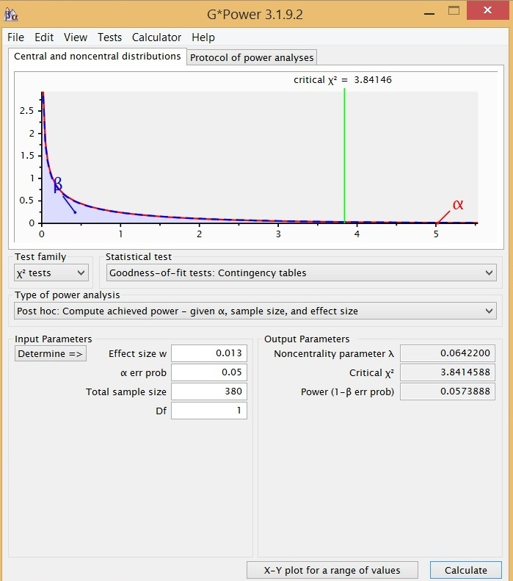

Output showing power of the Chi square test conducted

For decreasing the chances of Type II error, we should have power of at least 0.8, which indicates that we should probably consider having a larger sample size of at least 46443 students, as indicated in the output below.

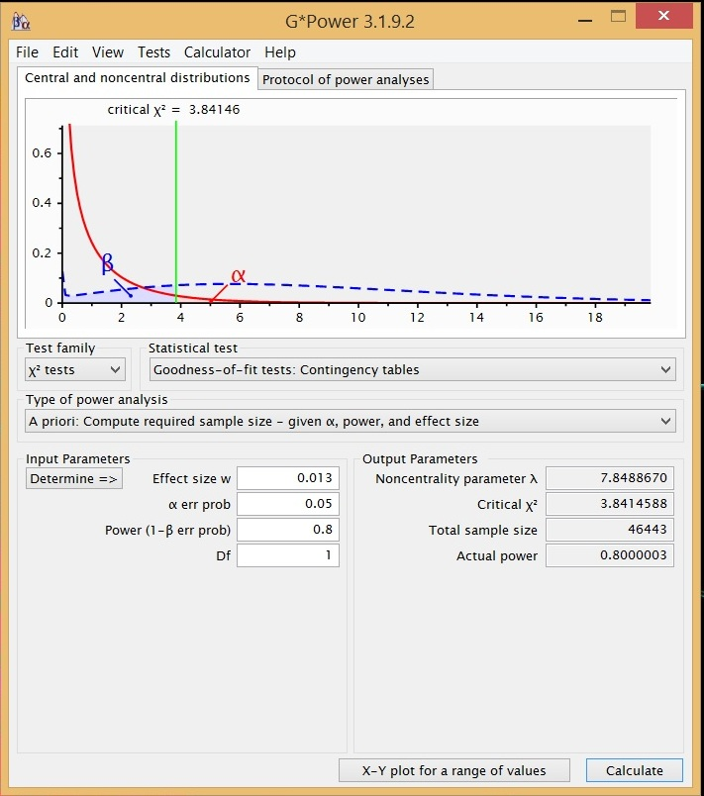

Output showing required sample size for an effective power

Thus to get more accurate results of the Chi- square test of independence and to analyze the relation between students having immediate family members on friend list and changing their privacy settings to restrict viewers of the content shared, we should probably collect more responses.

1. **DISCUSSION**

We conducted 3 major studies in which we tried to analyze the influence of social media on some aspects of the respondents’ life. As the respondents in the survey of the dataset where students, in our first study we tried to compare the tendency of the students to use Facebook for educational purpose over their years in school. We developed a nine variable scale ‘Facebook_In_School’ which defined the use of Facebook for all the individuals. We then ran an anova with the scale as a dependent variable and the years across school as an independent variable. We found the anova test to be significant which suggested that the tendency of students to use Facebook for activities related to school did vary across their year in school. However, we were not able get to any significant results from the post hoc tests

In our second study, our main aim was to analyze if the nature of social relationships of a person is correlated with their dependence on Facebook. For this study we used the Facebook Intensity Scale to determine the dependence on Facebook. To analyze the nature of the social relationships, we wanted to follow the Social Provisions scale. As the dataset contained only half of the variables required to compute the scale, we used a partial social provisions scale. The results showed that there is a very mild correlation between the two scales. We ran a linear regression to further analyze this relationship. The results showed that for every ten percent increase in the positive nature of social relationships, we expect a three percent increase in the dependence on Facebook. Thus, we were able to conclude that students having high score on the Social Provisions Scale were more likely to be dependent of Facebook.

We also examined if the presence of family members in students Facebook friend list might affect their decision to change the privacy settings of the content they post online. To analyze this, we ran a chi square test with two dichotomous variables about presence of family and customization of privacy settings. We were able to conclude that students having immediate family members were not likely to change their privacy setting such that only some of their friends can see the content the share. The power obtained was very small and hence there was a high probability of a type II error. It was found out that the study could be analyzed more accurately if we use a bigger sample size.

Thus we were able to make some valid conclusions about the effect Facebook has on the educational and social spheres of a student’s life. These results can be further used to analyze the above topics in depth and help in studying student attitudes about social media more accurately.

1. **REFERENCES**
2. Source: Facebook’s information page: <http://newsroom.fb.com/company-info/>
3. Pew Demographics 2015:

<http://www.pewinternet.org/2015/01/09/demographics-of-key-social-networking-platforms-2/>

1. Ophus, J. D., & Abbitt, J. T. (2009). Exploring the potential perceptions of social networking systems in university courses. *Journal of Online Learning and Teaching*, *5*(4), 639-648.
2. Towner, T., & Muñoz, C. (2011). Facebook and education: A classroom connection. *Educating educators with social media: Cutting edge technologies in higher education. Bingley, U, K.: Emerald*, *1*, 33-57.
3. (Roblyer, M., McDaniel, M., Webb, M., Herman, J., & Witty, J. V. (2010). Findings on Facebook in higher education: A comparison of college faculty and student uses and perceptions of social networking sites. *The Internet and Higher Education*, *13*(3), 134-140.
4. Bicen, H., & Cavus, N. (2011). Social network sites usage habits of undergraduate students: Case study of Facebook. *Procedia-Social and Behavioral Sciences*, *28*, 943-947.
5. Helliwell, J. F., & Putnam, R. D. (2004). The social context of well-being.*Philosophical transactions-royal society of London series B biological sciences*, 1435-1446.
6. Adler, P. S., & Kwon, S. W. (2002). Social capital: Prospects for a new concept. *Academy of management review*, *27*(1), 17-40.
7. i) Ellison, N. B., Steinfield, C., & Lampe, C. (2007). The benefits of Facebook

“friends:” Social capital and college students' use of online social network sites. Journal of Computer-Mediated Communication, 12, 1143–1168.

ii) Lampe, C., Ellison, N., & Steinfield, C. (2008). Changes in use and perception of Facebook. In Proceedings of the ACM 2008 Conference on Computer Supported Cooperative Work (pp. 721–730). ACM: New York

1. i) Greenhow, C., & Robelia, B. (2009a). Informal learning and identity formation in online social networks. Learning, Media and Technology, 34,119–140.

ii) Greenhow, C., & Robelia, B. (2009b). Old communication, new literacies: Social network sites as social learning resources. Journal of Computer-Mediated Communication, 14, 1130–1161.

iii) Madge, C., Meek, J., Wellens, J., & Hooley, T. (2009). Facebook, social integration and informal learning at university: “It is more for socialising and talking to friends about work than for actually doing work. Learning, Media and Technology, 34, 141–155.

iv) Selwyn, N. (2009). Faceworking: Exploring students’ education-related use of Facebook. Learning, Media and Technology, 34, 157–174.

1. Should teens. (2011, January 31). Retrieved from

<http://www.seattletimes.com/life/lifestyle/should-teens-friend-parents-on-facebook/>

1. Vitak, J., Ellison, N. B., & Steinfield, C. (2011, January). The ties that bond: Re-examining the relationship between Facebook use and bonding social capital. In *System Sciences (HICSS), 2011 44th Hawaii International Conference on*(pp. 1-10). IEEE.
2. Facebook Intensity Scale: <https://www.msu.edu/~nellison/TOIL/scales.html>
3. Cutrona, C.E. and D. Russell, “The Provisions of Social Relationships and Adaptation to Stress”, in W.H. Jones and D. Perlman (eds.) Advances in personal relationships (Vol. 1). Greenwich, CT: JAI Press, 1987, pp. 37-67.
4. Weiss, R.S., “The Provisions of Social Relationships”, in Z. Rubin (ed.), Doing Unto Others. Englewood Cliffs, NJ, Prentice-Hall, 1974, pp. 17-26.